**Lab Sheet 3**

Date – 08-04-2022

ASWIN G MENON

AM.EN.U4CSE20313

1. Write a program in MIPS assembly language that computes the area of a rectangle given the width and the height. The width and height are read from the standard input after prompting the user, and then the program computes the area and prints it on the standard output.

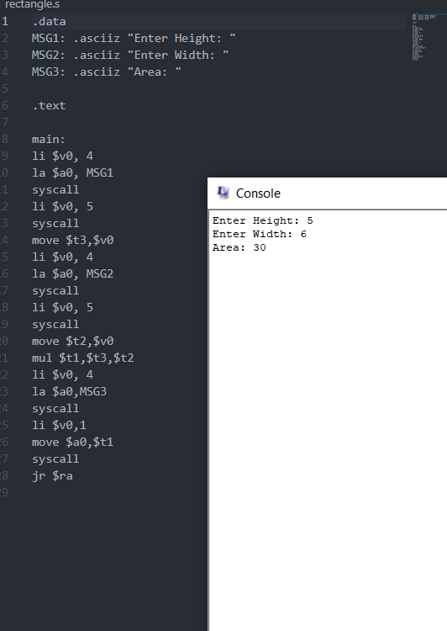

1. Write a program in MIPS assembly language to swap two values. Get input from the user and display the values on screen after swap operation.

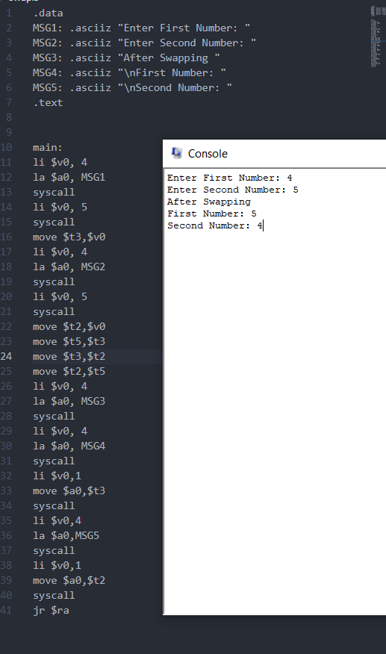

1. Write a program to check an entered number is odd or even.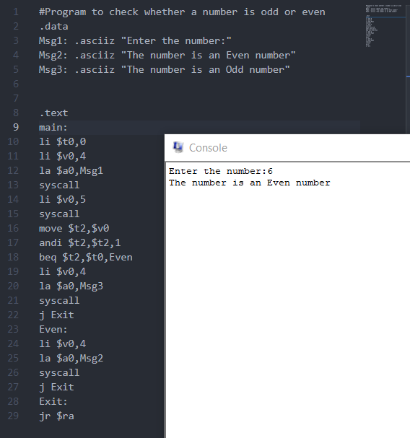
2. Write programs to evaluate the following expressions. The user should enter the variables, and the program should print back an answer. Prompt the user for all variables in the expression, and print the results in a meaningful manner. The results should be as accurate as possible.
3. 4x2 + 2x + 3.

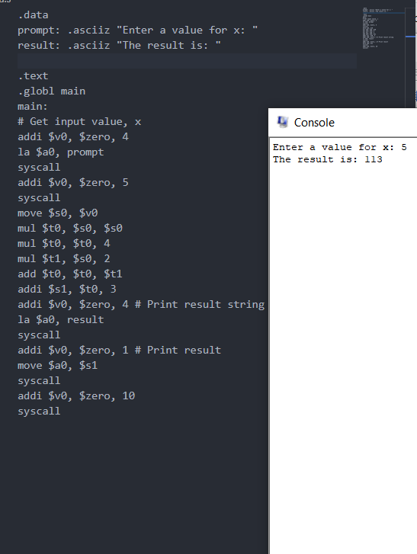

1. 5x + 3y +z

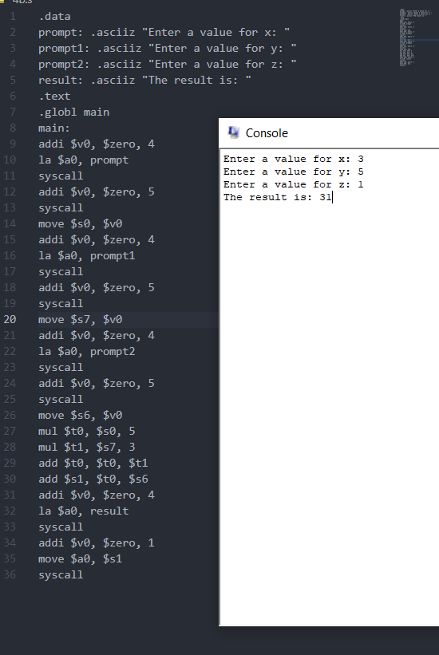

1. ((5x + 3y + z) / 2) * 3

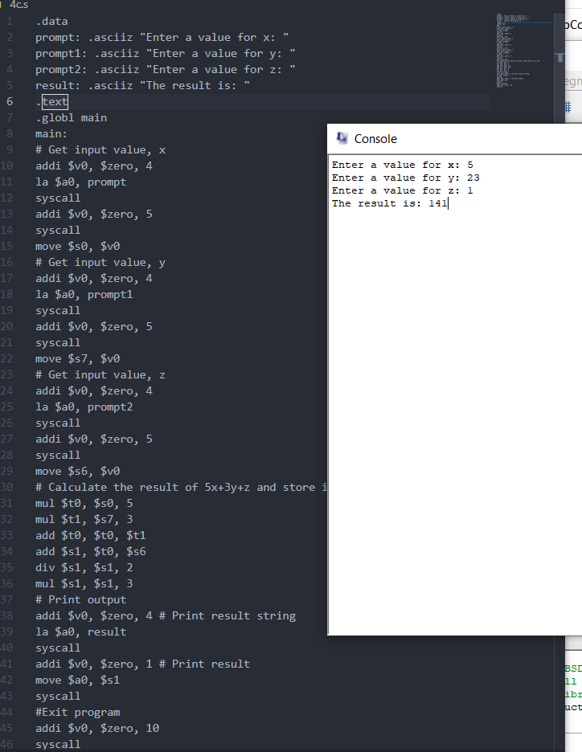

1. (4x / 3) * y



